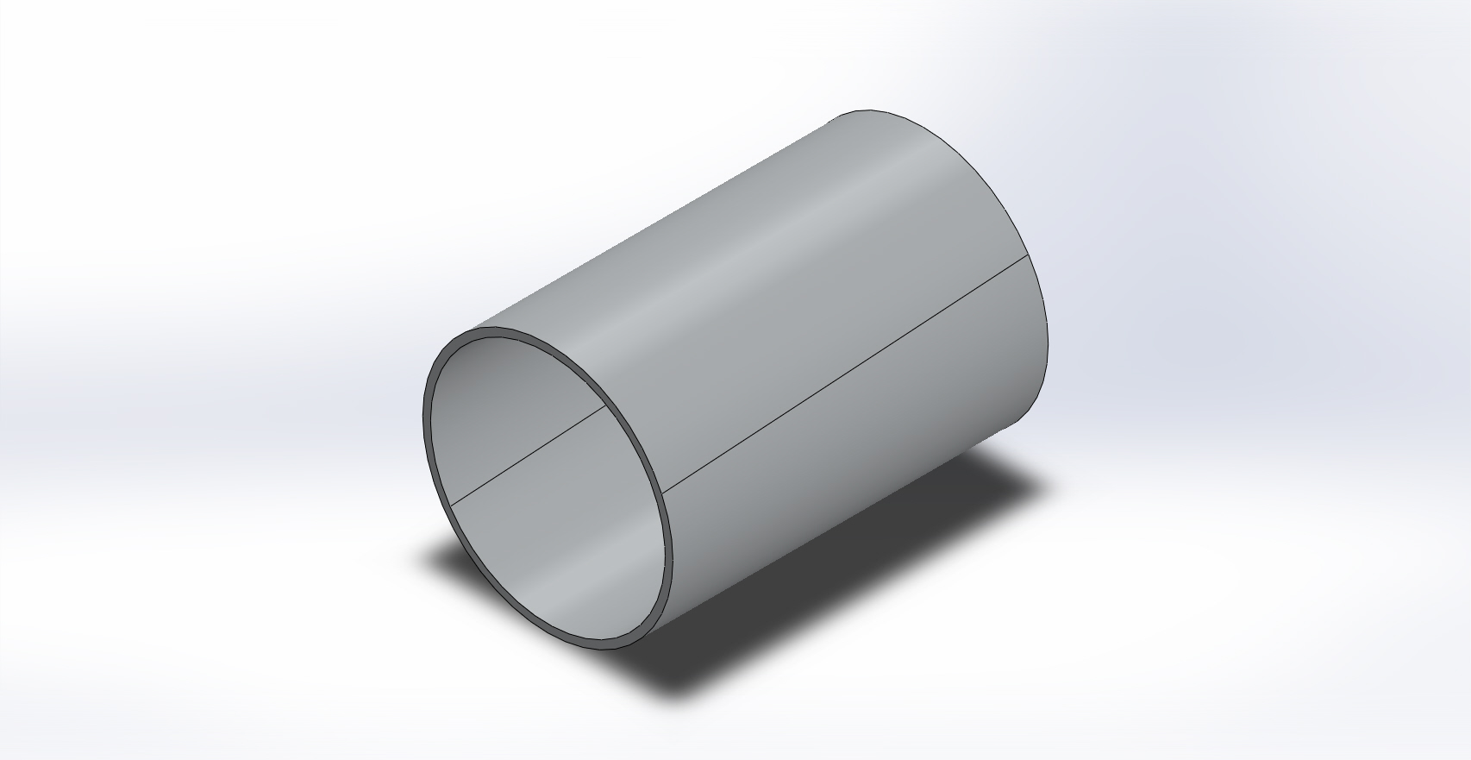 | Simulation of cylinder  Date: Thursday, December 13, 2012  Designer: Solidworks  Study name: SimulationXpress Study  Analysis type: Static  Table of Contents  Description 1  Assumptions 2  Model Information 2  Material Properties 3  Loads and Fixtures 3  Mesh Information 4  Study Results 6  Conclusion 8

Description
No Data

Assumptions

Model Information

Model name: cylinder
Current Configuration: Default
Solid Bodies
Document Name and Reference | Treated As | Volumetric Properties | Document Path/Date Modified
Boss-Extrude1 | Solid Body | Mass:3.23175 kg  Volume:0.00119694 m^3  Density:2700 kg/m^3  Weight:31.6711 N | C:\Users\Arko\Desktop\Tesla\HABEX Project\HABEX 2\ENV Chamber\cylinder.SLDPRT  Dec 13 23:08:46 2012

Material Properties
Model Reference | Properties | Components
 | Name: 6061-T6 (SS)  Model type: Linear Elastic Isotropic  Default failure criterion: Max von Mises Stress  Yield strength: 2.75e+008 N/m^2  Tensile strength: 3.1e+008 N/m^2 | SolidBody 1(Boss-Extrude1)(cylinder)

Loads and Fixtures
Fixture name | Fixture Image | Fixture Details
Fixed-1 |  | Entities: 2 face(s)  Type: Fixed Geometry

Load name | Load Image | Load Details
Pressure-1 |  | Entities: 1 face(s)  Type: Normal to selected face  Value: 14  Units: psi

Mesh Information
Mesh type | Solid Mesh
Mesher Used: | Standard mesh
Automatic Transition: | Off
Include Mesh Auto Loops: | Off
Jacobian points | 4 Points
Element Size | 0.488471 in
Tolerance | 0.0244236 in
Mesh Quality | High

Mesh Information - Details
Total Nodes | 15029
Total Elements | 7419
Maximum Aspect Ratio | 6.3767
% of elements with Aspect Ratio < 3 | 97.6
% of elements with Aspect Ratio > 10 | 0
% of distorted elements(Jacobian) | 0
Time to complete mesh(hh;mm;ss): | 00:00:03
Computer name: | ARKO-PC

Study Results

Name | Type | Min | Max
Stress | VON: von Mises Stress | 252071 N/m^2  Node: 1333 | 1.81689e+006 N/m^2  Node: 14971
cylinder-SimulationXpress Study-Stress-Stress

Name | Type | Min | Max
Displacement | URES: Resultant Displacement | 0 mm  Node: 1 | 0.00210212 mm  Node: 38
cylinder-SimulationXpress Study-Displacement-Displacement

Name | Type
Deformation | Deformed Shape
cylinder-SimulationXpress Study-Displacement-Deformation

Name | Type | Min | Max
Factor of Safety | Max von Mises Stress | 151.358  Node: 14971 | 1090.96  Node: 1333
cylinder-SimulationXpress Study-Factor of Safety-Factor of Safety

Conclusion

