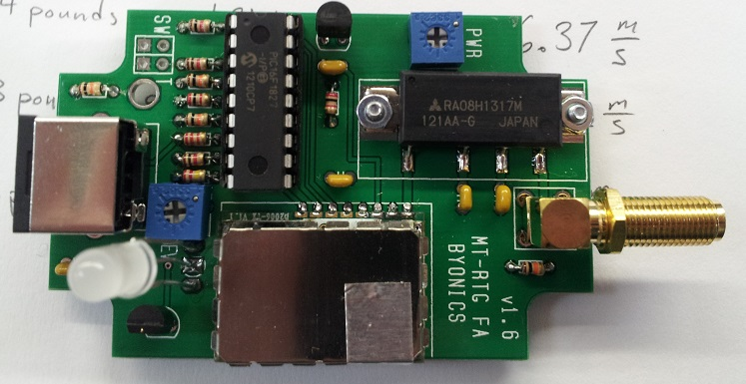

HABEX – Radio Alpha – Micro Trak RTG FA – Circuit Analysis

Circuit Analyst: Ara Kourchians

Abstract:
The goal of this analysis is to determine nominal, minimum, and maximum operating conditions. The required parameters are:

Operating Input Voltage Range: $8v≤V_{in}≤15.0v$

Expected Output Voltage Range: $4.8v≤V_{5v}≤5.2v$

Operating Temperature Range: -30C to +80C

RF Power Range: 1.75W - 2.25W

Operating Input Voltage Range

In this analysis $V_{in}=V_{12v}$ which is ideally 12v. From this analysis we can determine how much variation would allow the device to function within margin.

V-Telemetry Circuit

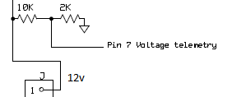

Operating Voltage: $0v≤V_{in}≤(Maximum Input Voltage of Pin 7)$
Based on the PIC16F1826 datasheet: Maximum Input Voltage of Pin 7 – 5.5v
$$5.5v= \left(\frac{2kΩ}{2kΩ+ 10kΩ}\right)*V_{in max}$$
The maximum voltage for the V-Telemetry circuit is:
$$V_{in max}=33v$$
Thus, the operating voltage for the V-Telemetry circuit is:

$$0v≤V_{in}≤33v$$
Based on the resistor datasheet: Operating Temperature:

-40C to +125C

5v Regulator Circuit
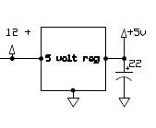
Based on the GJ7805 datasheet: Operating Input Voltage Range:
$$7.5v≤V_{in}≤20v$$

Based on the GJ7805 datasheet: Operating Temperature:

-40C to +125C

RF Power Amplifier Circuit

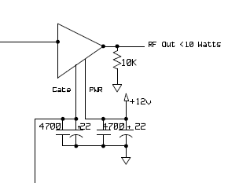
$$V_{GG}$$
RF INPUT

Based on the RA08H1317M datasheet: Operating Input Voltage Range:
$$4v≤V_{in}≤15.0v$$

Based on the RA08H1317M datasheet: Operating Temperature Range:

-30C to +125C
Circuit | Operating Input Voltage Range | Operating Temperature Range
V-Telemetry Circuit | $$0v≤V_{in}≤33v$$ | -40C to +125C
5v Regulator Circuit | $$7.5v≤V_{in}≤20v$$ | -40C to +125C
RF Power Amplifier Circuit | $$4v≤V_{in}≤15.0v$$ | -30C to +125C
Final Parameters: | $$7.5v≤V_{in}≤15.0v$$ | -30C to +125C

Operating Input Voltage Range: $7.5v≤V_{in}≤15.0v$

BATTERY VOLTAGE MUST WITHIN THE OPERATING INPUT VOLTAGE

Operating Logic Voltage Range

In this analysis $V_{in}=V_{5v}$ which is ideally 5v. We compare the 5v Regulators output (with error) to the logic voltage range. From this analysis we can determine how much variation would allow the device to function within margin.

5v Regulator Output Circuit

Using the GJ7805 datasheet:

Output Voltage Range: $4.8v ≤ V_{5v} ≤5.2v$ typically 5v

Based on the GJ7805 datasheet: Operating Temperature:

-40C to +125C

PIC16F1826 Circuit

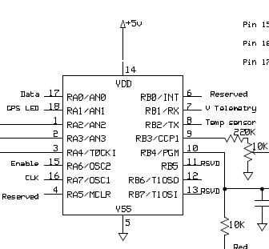
Based on the PIC16F1826 datasheet: Operating Input Voltage Range:
$$1.8v≤V_{5v}≤5.5v$$

Based on the PIC16F1826 datasheet: Operating Temperature Range:

-40C to +125C

MCD2006G Circuit
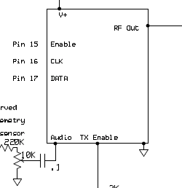
Based on the MCD2006G datasheet: Operating Input Voltage Range:
$$2.5v≤V+ ≤4.5v$$
Since the MCD2006G uses a LDO to drop the voltage from 5v to 3.3v, the logic voltage variations affect the LDO, which directly affects the MCD2006G:

$$4.5v≤V_{5v}≤12v$$
Based on the MCD2006G datasheet: Operating Temperature Range:

-40C to +85C

BJT Circuit
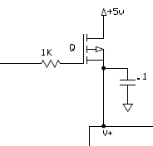
Based on the 2N3906 datasheet: Operating Input Voltage Range:
$$0v≤V_{5v}≤40v$$

Based on the 2N3906 datasheet: Operating Temperature Range:

-55C to +150C
Circuit | Operating Output Voltage Range | Operating Temperature Range
5v Regulator Output Circuit | $$4.8v≤V_{5v}≤5.2v$$ | -40C to +125C
PIC16F1826 Circuit | $$1.8v≤V_{5v}≤5.5v$$ | -40C to +80C
MCD2006G Circuit | $$4.5v≤V_{5v}≤12v$$ | -30C to +125C
BJT Circuit | $$0v≤V_{5v}≤40v$$ | -55C to +150C
Final Parameters: | $$4.5v≤V_{5v}≤5.5v$$ | -30C to +80C

Operating Output Voltage Range: $4.5v≤V_{5v}≤5.5v$

Expected Output Voltage Range: $4.8v≤V_{5v}≤5.2v$

OPERATING VOLTAGE IS WITHIN THE EXPECTED OUTPUT VOLTAGE

Operating Temperature Range

In this analysis we determine the safe operating temperature of the device as a whole. Using the Temperature ranges from the data above we can conclude the following:

Operating Temperature Range: -30C to +80C

RF Power Range

Using the RA08H1317M datasheet:
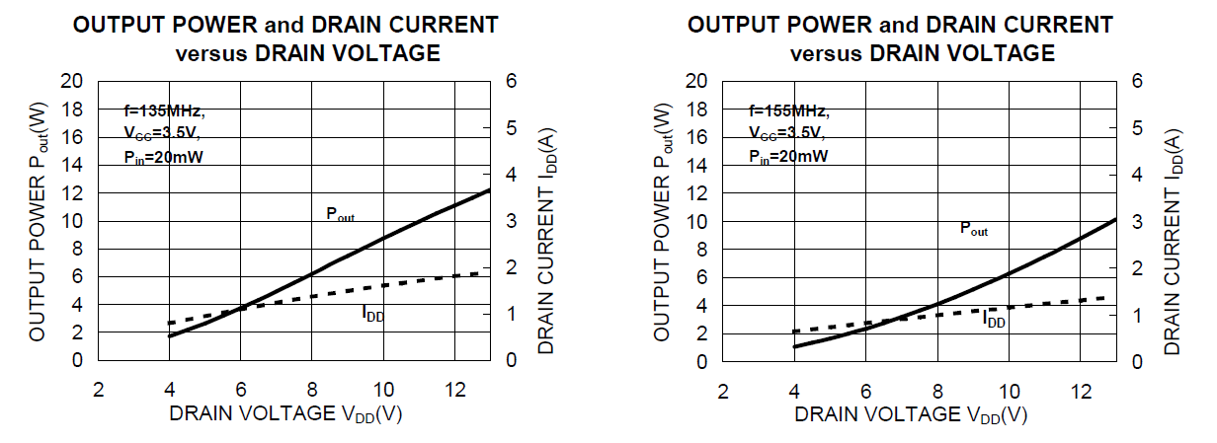
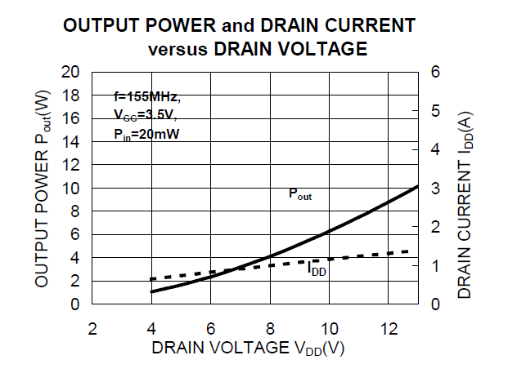
10W
4W
13.2V
8V

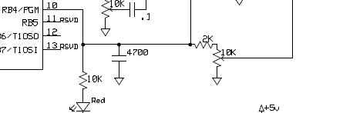

From this circuit we can see the gate is controlled by a voltage divider of the logic voltage ( $V_{5v}$ )
Our target power is 2W:
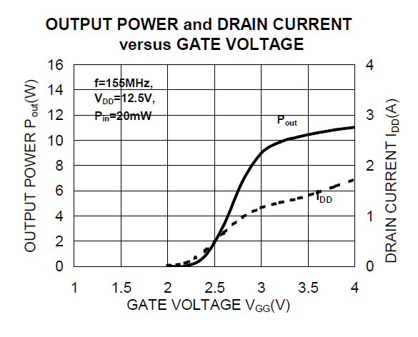
Target Gate Voltage: 2.5V
Target Power:
2W

$$2.5v= V_{5v}\left(\frac{R}{2kΩ+ R}\right)$$

Ideal/nominal case:
$$2.5v= 5v\left(\frac{R}{2kΩ+ R}\right)$$

$$R=2.0kΩ$$

From here, we fix R since we cannot change that during flight. We then apply the maximum and minimum logic voltage to determine how much of a power variation to expect.
Max logic voltage case:
$V_{gg max}= 5.2v\left(\frac{2kΩ}{2kΩ+ 2kΩ}\right)$

$V_{gg max}=2.60v$ $P_{RF OUT MAX}=2.25W$

Min logic voltage case:
$V_{gg min}= 4.8v\left(\frac{2kΩ}{2kΩ+ 2kΩ}\right)$

$V_{gg min}=2.40v$ $P_{RF OUT MIN}=1.75W$

Expected RF Power: 2 Watt

RF Power Variation Range: 1.75W - 2.25W

