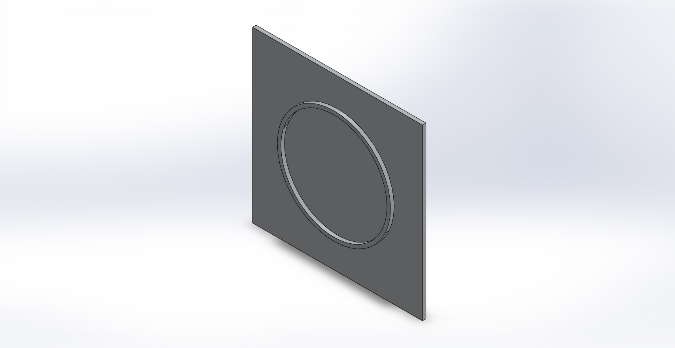 | Simulation of bottom  Date: Thursday, December 13, 2012  Designer: Solidworks  Study name: SimulationXpress Study  Analysis type: Static  Table of Contents  Description 1  Assumptions 2  Model Information 2  Material Properties 3  Loads and Fixtures 3  Mesh Information 4  Study Results 6  Conclusion 8

Description
No Data

Assumptions

Model Information

Model name: bottom
Current Configuration: Default
Solid Bodies
Document Name and Reference | Treated As | Volumetric Properties | Document Path/Date Modified
Boss-Extrude2 | Solid Body | Mass:1.66015 kg  Volume:0.000614871 m^3  Density:2700 kg/m^3  Weight:16.2695 N | C:\Users\Arko\Desktop\Tesla\HABEX Project\HABEX 2\ENV Chamber\bottom.SLDPRT  Dec 13 23:17:01 2012

Material Properties
Model Reference | Properties | Components
 | Name: 6061 Alloy  Model type: Linear Elastic Isotropic  Default failure criterion: Max von Mises Stress  Yield strength: 5.51485e+007 N/m^2  Tensile strength: 1.24084e+008 N/m^2 | SolidBody 1(Boss-Extrude2)(bottom)

Loads and Fixtures
Fixture name | Fixture Image | Fixture Details
Fixed-1 |  | Entities: 1 face(s)  Type: Fixed Geometry

Load name | Load Image | Load Details
Pressure-1 |  | Entities: 1 face(s)  Type: Normal to selected face  Value: -14  Units: psi

Mesh Information
Mesh type | Solid Mesh
Mesher Used: | Standard mesh
Automatic Transition: | Off
Include Mesh Auto Loops: | Off
Jacobian points | 4 Points
Element Size | 0.353369 in
Tolerance | 0.0176684 in
Mesh Quality | High

Mesh Information - Details
Total Nodes | 16443
Total Elements | 8301
Maximum Aspect Ratio | 6.5161
% of elements with Aspect Ratio < 3 | 92.6
% of elements with Aspect Ratio > 10 | 0
% of distorted elements(Jacobian) | 0
Time to complete mesh(hh;mm;ss): | 00:00:03
Computer name: | ARKO-PC

Study Results

Name | Type | Min | Max
Stress | VON: von Mises Stress | 3133.15 N/m^2  Node: 11771 | 1.3092e+007 N/m^2  Node: 1160
bottom-SimulationXpress Study-Stress-Stress

Name | Type | Min | Max
Displacement | URES: Resultant Displacement | 0 mm  Node: 1 | 0.0923336 mm  Node: 8617
bottom-SimulationXpress Study-Displacement-Displacement

Name | Type
Deformation | Deformed Shape
bottom-SimulationXpress Study-Displacement-Deformation

Name | Type | Min | Max
Factor of Safety | Max von Mises Stress | 4.2124  Node: 1160 | 17601.6  Node: 11771
bottom-SimulationXpress Study-Factor of Safety-Factor of Safety

Conclusion

