HABEX2
Reference Guide

Revision Date: March 24th, 2013

Goal:
Priority #1 is safety. The goal is to successfully launch and recovery a high altitude balloon which will start near sea level, rise to 31,000m, and safely return to the surface all while transmitting the location of the payload. Ground teams must be prepared and trained to handle all radio communication from other teams and radio downlink from the payload.

Mission Overview:
Launch Information:

Saturday March 30th, 2013 10:00:00am PST
Lat: +34.109313 (OR +34deg 6mins 33.5268seconds)
Long: -115.682892 (OR -115deg 40mins 58.4106seconds)
Elevation: Ground 395m
Payload mass + Parachute mass = Total Mass: 1.76901kg = 3.90lbs
Payload Density follows Part 101
Balloon: Kaymont 1200 Sounding Balloon
Radio Equipment: Ham Radio @ 144.390 using my callsign N6ARA using the APRS repeater system
GPS: Yes, this information is relayed to the radio
Rate of ascent (est): 5.83m/s
Rate of decent (est): 6.37m/s
Estimated flight duration: 89 minutes

Landing Information:

Saturday March 30th, 2013 11:29:00am PST
Lat: +34.8904
Long: -114.5884
Elevation: Ground (~500m above sea level)

Estimate path of flight:
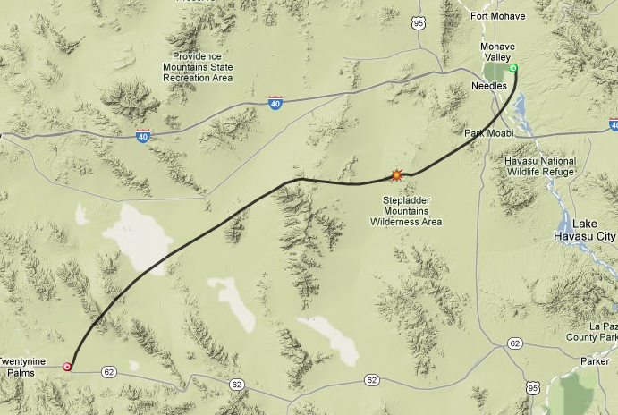

Launch/Chase & Recovery Teams Road plan:
Recovery teams:
2 hours of driving

- Launch/Chase teams and Recovery teams ALL meet at the launch site to test equipment
  - Test all radios and communication
  - Plan fueling and GO/NO-GO

- Recovery teams then head out for an approximately 2 hour drive to estimated landing zone
Recovery teams:
<30mins of driving

Launch/Chase teams:
2 Hours of driving

- Once all teams have reached their respective locations, and the checklist is complete and all teams have checked in with working equipment, we launch.

- Launch/Chase team beings driving and chasing to estimated landing zone

- Recovery teams must be tracking and sharing with COMM and OPS the landing zone

- Once the balloon has landed, and we have a lock on where it has landed, we pick a meeting area to plan how to drive out and recover the payload.

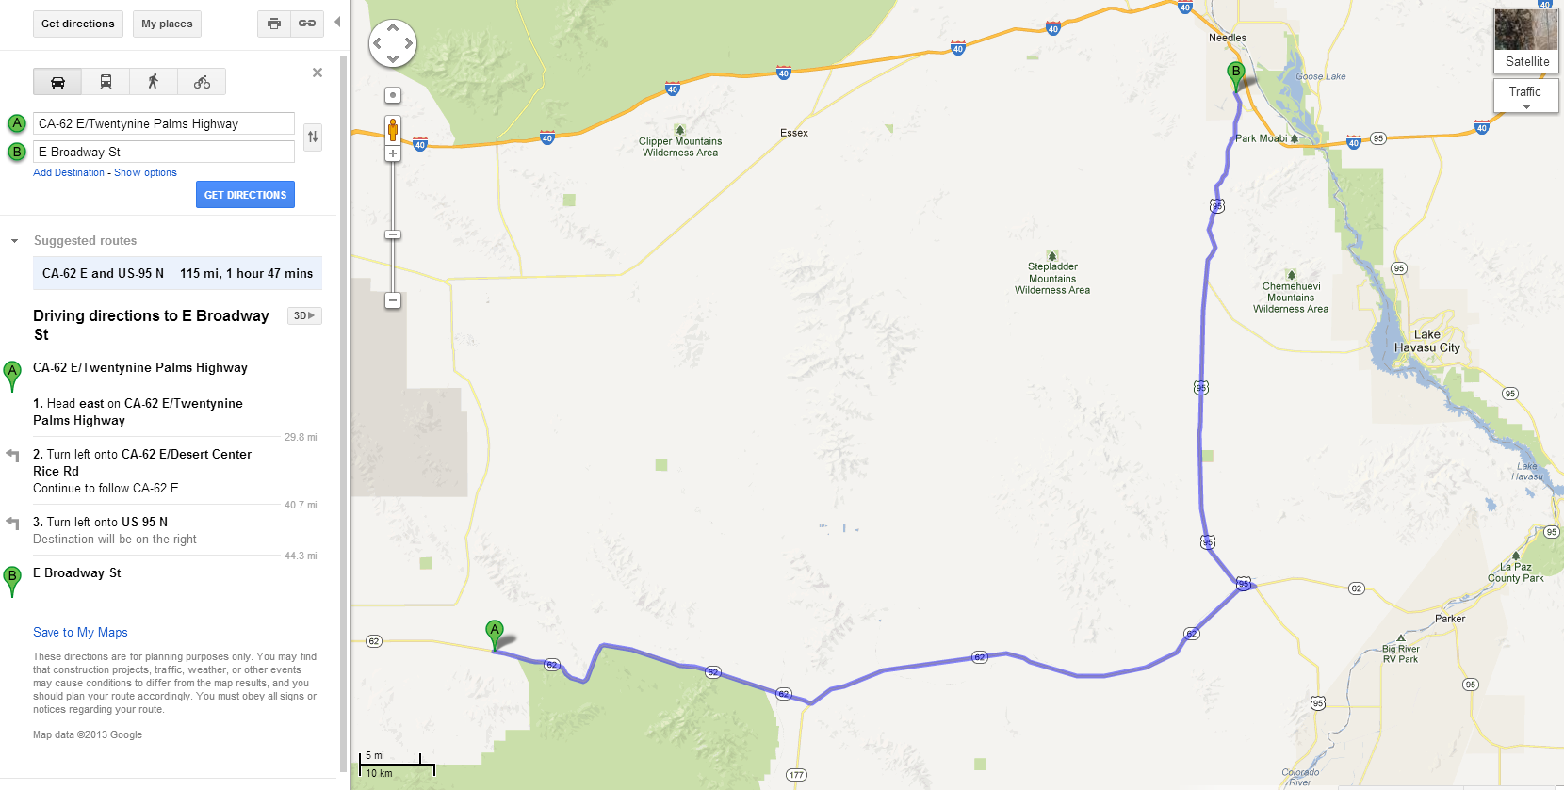
Car Schematic/Setup:
Mag Mount Antenna
0

2m Band
Radio Tuned to 144.390Mhz for APRS decoding

INVERTER
0
Laptop Decoding APRS
12V Line
Inverter
12V Battery

Tablet
AC Power to Chargers
0

0
Smartphone

MiFi
70cm Band Radio for communication

Timeline:
Following timeline is in Pacific Standard Time:
5:30AM – Wake up
6:45AM – Leave Cabin
7:00AM – Fill up gas
7:30AM – ALL teams arrive at launch site
7:45AM – Power up all devices, have teams decode and test equipment
8:00AM – Recovery teams North, East, West, South & Overshoot head to respective locations
8:45AM – Payload is prepared and tested, clean up everything except filling station
9:00AM – Filling station is prepared
9:30AM – Begin filling balloon
9:45AM – Balloon is filled and tied to parachute/payload
9:55AM – Pack up everything, and have cars running and on standby
9:55AM – Check in with all recovery teams and assure they are ready
10:00AM – Launch Balloon
10:01AM – Launch/Chase teams start heading toward estimated landing zone
10:02AM – All teams check in with status of contact with payload
10:03AM – Tracking balloon until landing, coordinate and check-in with COMM every 30min
11:29AM – Estimated HABEX touchdown!
11:30AM – Coordinate with COMM and figure out final landing location, KEEP TRACKING
11:45AM – Finalize and agree on HABEX touchdown location
12:00PM – Regroup near landing site, COMM will specify, and begin planning recovery

Startup Procedure:
- Turn on the car
- Plug-in inverter, assure it’s powered
  - Note the equipment and power draw to assure you don’t draw too much from the battery
- Plug-in laptop to power
- Power laptop
- Place mag mount antenna and run the cable into the car, be careful to not pinch it
- Connect the mag mount antenna to the radio
- Connect & power radio
Using SDR#:
- Follow directions at the below link to get SDR# set up: rtlsdr.org/softwarewindows
- Radio WFM
- Filter Bandwidth 14000
- VFO Approx 144.390 MHz

Using Ham radio:
- Tune radio to 144.390Mhz
- Connect audio output of the radio to the microphone input of the laptop
- Set radio to 0 squelch (open)

- Setup packet receiving software:
Using MixW:
- Set Mode -> Packet
- Set Mode -> Mode Settings -> Modem -> VHF 1200 baud (Standard)
- Go to Configure -> Sound Device Settings
- Select your Stereo Mix for Input
- Speakers for output (to monitor)
- Watch the waterfall and adjust the volume until the waterfall is a light blue (dark blue or black is too low volume, and dark green, yellow, orange, red means too loud.
  - NOTE: You will see transmissions and they may peak to orange or red, but that’s ok, you want the background noise to be light blue.
  - If you do not see a waterfall, check and volume and squelch
  - Try going to Sound Devices Settings and selecting the input device again
- Click the center box (MixW will not decode the AX.25 packets if the center box is not selected.
- You should see other stations packets showing up as well as a packet from N6ARA every 2 minutes.
- You can adjust the volume to fine tune, as you adjust you should see the rate of incoming packets increase as you adjust volume. This may not always work and could take some time to tune.

If you have done everything correctly, it should like something like this:
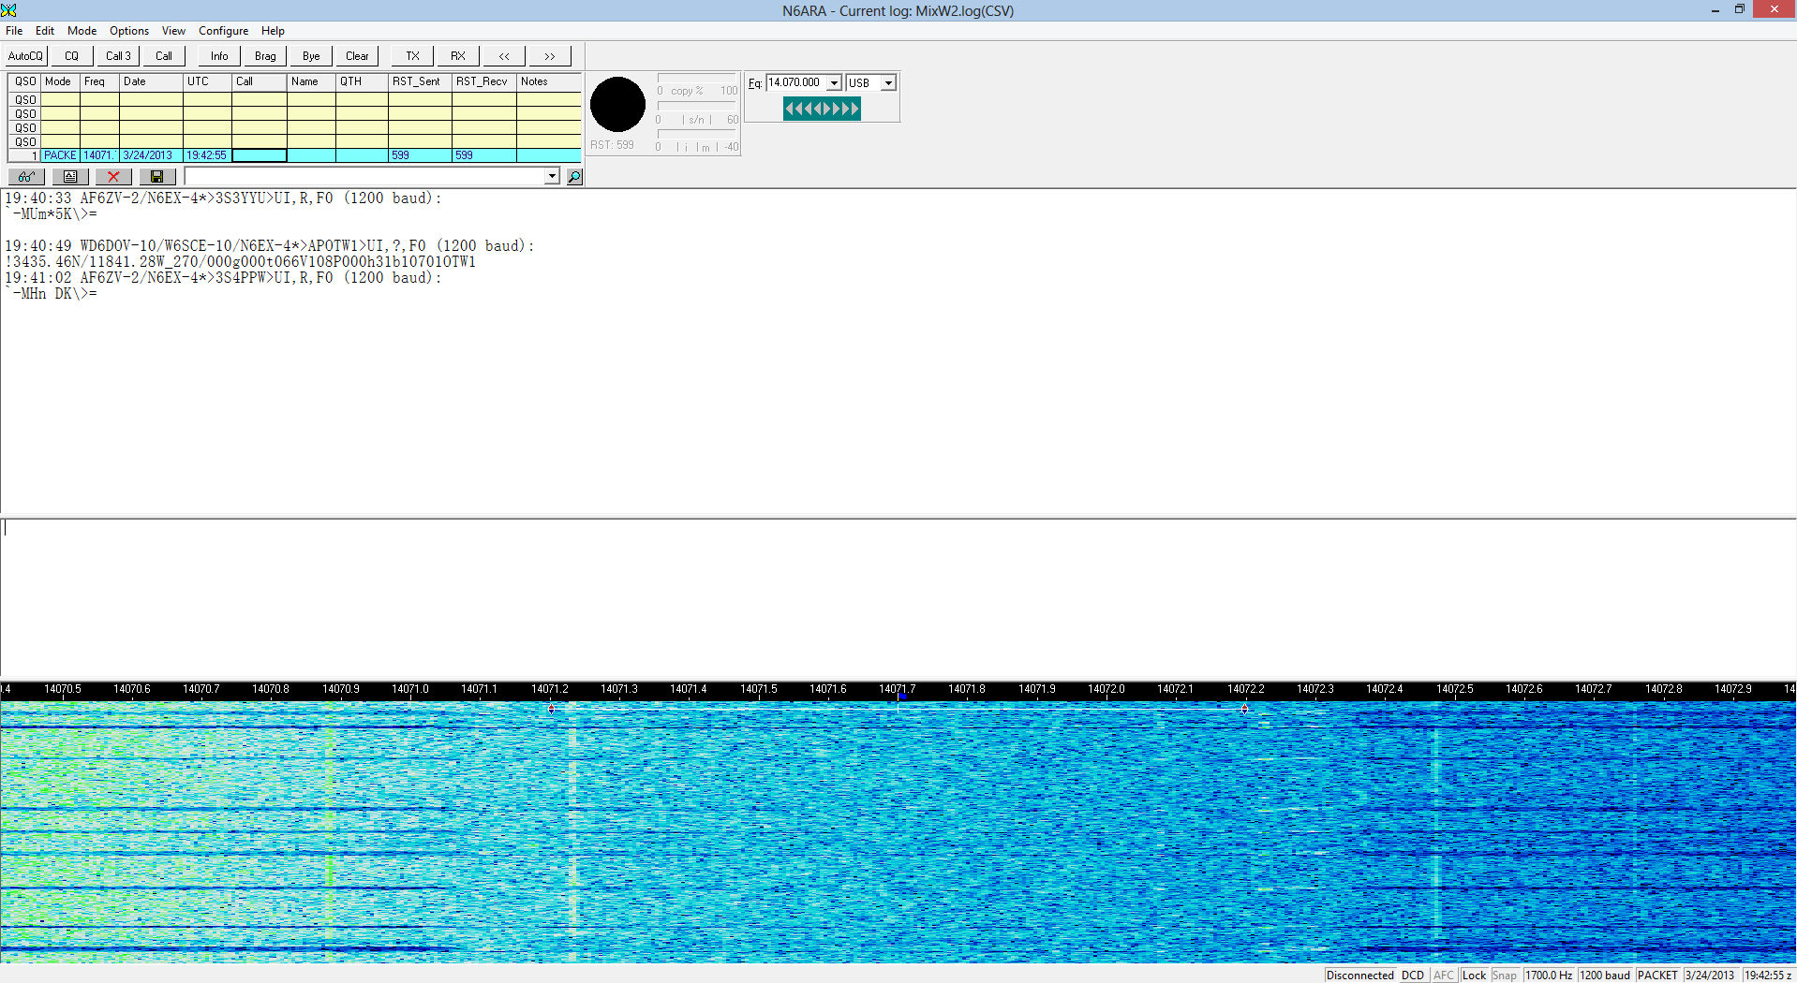
Packets show up here

MAKE SURE YOUR CURSOR IS ALWAYS SELECTED HERE, EXCEPT WHEN COPY/PASTING TO APRS DECODER, REMEMBER TO RETURN TO THIS WINDOW AND SELECT THIS BOX

Nice light blue waterfall

- Start up the APRS Decoding Program (credits to Davo)
  - Run the program
    - WINDOWS: Run web2py.exe in the "habex 2 aprs" folder
    - MAC: Run habex_2_aprs_mac.app
    - LINUX: Run web2py.py using Python 2.4 or newer ("python web2py.py" in terminal)
  - Make sure "Local (IPv4) (127.0.0.1)" is selected
  - Leave "Choose Password" blank
  - Click "start server"
  - Hit "OK" on the "no password..." error
  - The Decoder will open in your web browser.
  - If it doesn't open you can get to it by browsing to http://127.0.0.1:8000 in your web browser
- Every time you see a packet from N6ARA in MixW
  - Copy/Paste the packet to the APRS Decoder
  - MAKE SURE TO UPDATE THE DESTINATION AND PACKET EVERYTIME

The raw packet will look like this:

N6ARA/WIDE1-1/WIDE2-1>S4PRTQUI,?,F0:
`.+Gl#PO/"4q}HABEX|!V%@'b|!w!u!

Copy the required sections of your packet into the form below Sample Packet:

N6ARA/WIDE1-1/WIDE2-1>S4PRTQUI,?,F0:
`.+Gl#PO/"4q}HABEX|!V%@'b|!w!u!

Green Text = Sender Callsign
Orange Text = Destination Callsign (Required!)
Red Text = Packet (Required!)

NOTE: The destination callsign is a part of the packet, it shows up after the “WIDE2-1>” and ends before “UI,?,F0:”
NOTE: The packet itself is the ENTIRE next line. Including any and all symbols!!
- You should now see Latitude, Longitude, and Altitude.
- The offline maps should give you Google maps pinpoint of the current position of HABEX2, the software will log every time you copy and paste in sender,destination,packet.
- Every few packets, please write these down on paper!! Yes this ancient papyrus based technology is highly reliable and does not require power. This step is taken as a backup.

Debugging / Troubleshooting:

Unable to see packets in MixW?

    - Go to the Configuration->Sound Device Settings and select the correct audio inputs

    - Adjust the volume on the radio until the waterfall is LIGHT BLUE. Black and dark blue means it's too low, and green, yellow, and red means too high. You should see other data coming in if you are outside. Leave the squelch open.
    - Select the box above the waterfall

Teams Info:
FINAL PRINT WILL INCLUDE THIS INFORMATION:
Name | Email | Phone Number | Team | Sub Team | Equipment | Vehicle | Fri | Sat | Sun | Reliability (5=reliable, 1=not very reliable) | Ready

Frequency Plan:
APRS Decoding:
Frequency: 144.390 MHz
Packet: AX.25
Baud: 1200baud

Communication:
TBD by JEREMY

Goal as a station:
  - Decode APRS packets, looking for N6ARA
  - Find high ground
  - Find internet
  - Report to COMM when:
    - You first setup and start decoding
    - Every 30 minutes with a check-in and status
    - If you are having issues decoding or unable to pick-up HABEX2
  - Report directly to COMM

